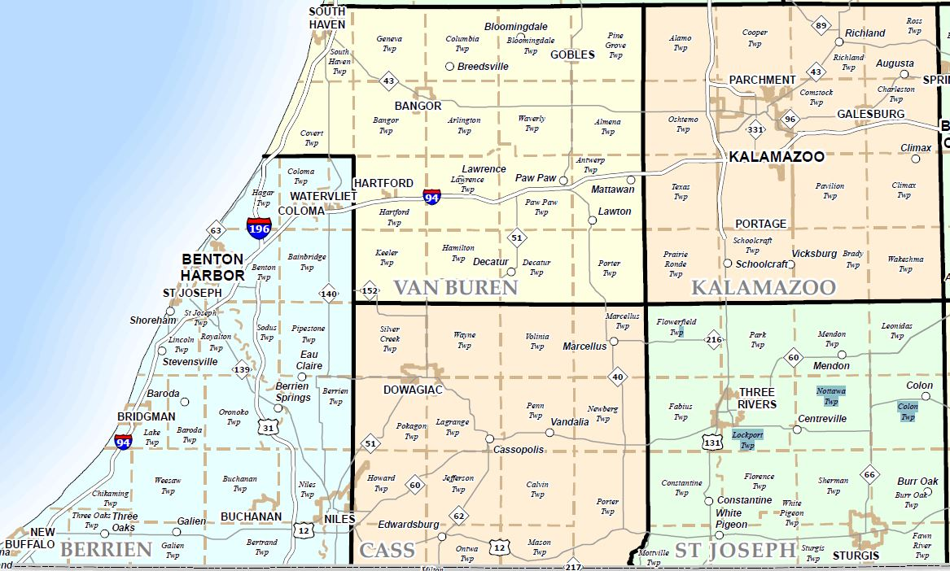

County Name | County Code | MSA code: | Census Tracts
Cass County | 027 | 43780 | Entire County (10.00, 11.00, 12.00, 15.00, 16.00, 17.00, 18.00, 19.00, 20.00, 21.00, 22.00)
Van Buren County | 159 | 28020 | Porter Township (116.00)  Decatur Township (116.00)  Keeler & Hamilton Township (115.00)
St. Joseph | 149 | N/A | West Half (401.00, 402.00, 403.00, 404.00, 409.00, 411.00, 412.00, 414.00)

Branch locations: (all branches have an ATM on location that accepts deposits)
Marcellus Cassopolis Edwardsburg
115 W. Main St 110 Spencer St 69139 M-62
Marcellus, MI 49067 Cassopolis, MI 49031 Edwardsburg, MI 49112
Census Tract 17.00 Census Tract 21.00 Census Tract 18.00

